Section C — Mini Capstone Project

Qus. Mini Project: TechLaunch Startup Network Build & Fault Diagnosis Objective: Build a complete two-VLAN network for a startup, then diagnose and resolve a Router-ona-Stick failure following a power outage — combining VLAN segmentation, trunking, inter-VLAN routing, and structured fault-finding into one exercise.

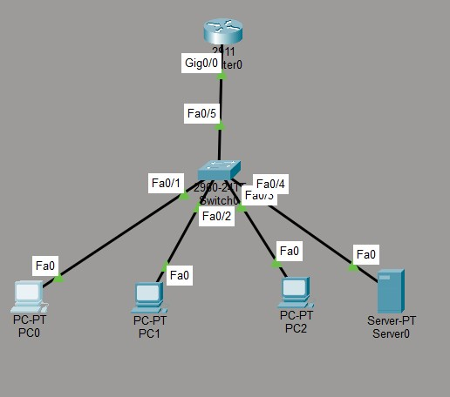

IP plan
Device | VLAN | IP Address | Gateway
PC0 Marketing | 10 | 192.168.10.10/24 | 192.168.10.1
PC1 Marketing | 10 | 192.168.10.11/24 | 192.168.10.1
PC2 Engineering | 20 | 192.168.20.10/24 | 192.168.20.1
File Server | 20 | 192.168.20.20/24 | 192.168.20.1
R1 G0/0.10 | 10 | 192.168.10.1/24 | —
R1 G0/0.20 | 20 | 192.168.20.1/24 | —

Configure the switch
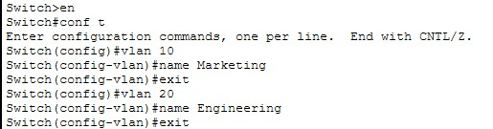

Assign ports
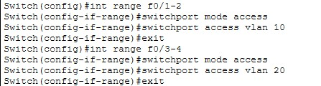

Configure trunk
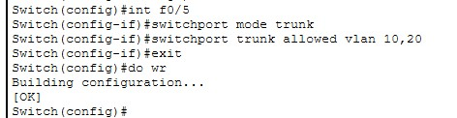

Configure Router
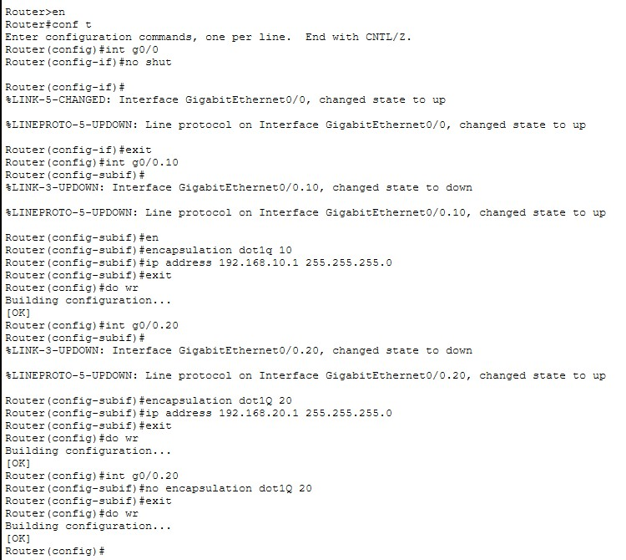

Test the working network
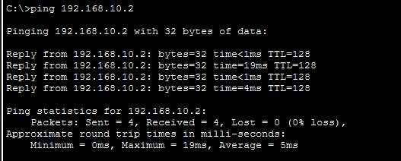

Engineering gateway troubleshooting
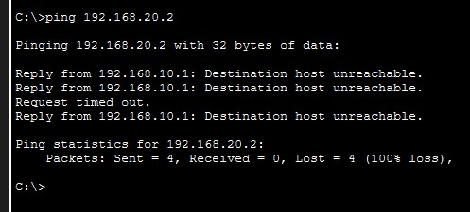

Switch verification commands
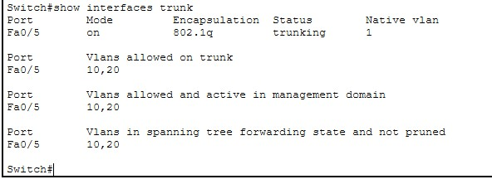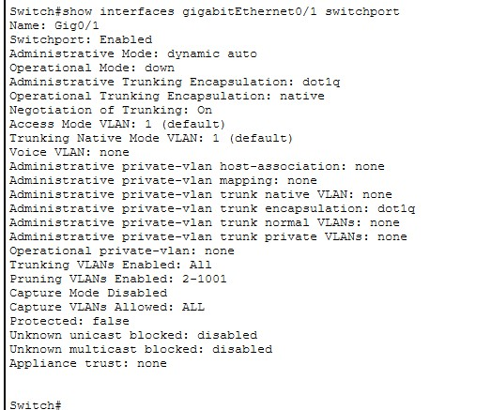

Router verification
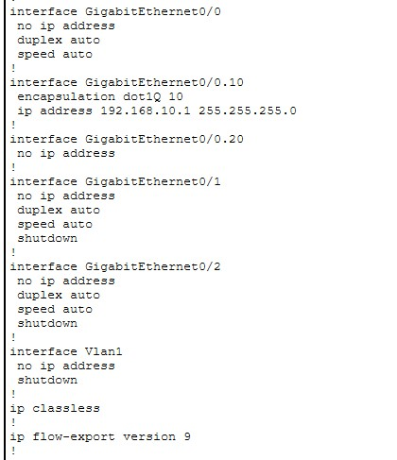

Root cause identified.
The VLAN 20 Router-on-a-Stick sub-interface is missing its 802.1Q encapsulation.

Fix the fault

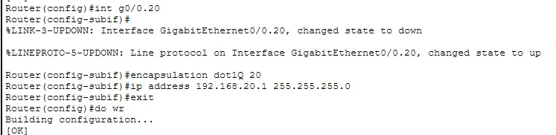

Now test again
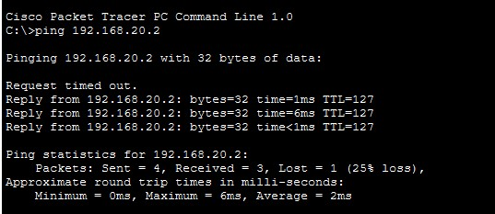
Inter-VLAN routing restored.
Configuration:
VLAN 10 and VLAN 20 were created on the switch and access ports were assigned to their respective departments. The switch-router connection was configured as an 802.1Q trunk. Router subinterfaces G0/0.10 and G0/0.20 were configured as the default gateways for the two VLANs.

Fault:
After simulating a router post-power-outage failure, Marketing devices could communicate with devices in their own VLAN but could not reach the Engineering file server.

Root Cause:
The encapsulation dot1Q 20 configuration was missing from router sub-interface G0/0.20.
Therefore, VLAN 20 traffic could not be correctly processed by the Router-on-a-Stick configuration.

After applying the configuration, Marketing could successfully ping the Engineering gateway and file server, confirming that inter-VLAN routing had been restored.

